Possessive Determiners

🔹 What Are Possessive Determiners?
# Source: AI Source: Provided by: [Data Path: Persons Table -> ID Column: 1, Name_En Column: Motasem Essam] -> From: [Chatgpt (GPT-4-turbo)] on [7/28/2025]
Possessive determiners (also called possessive adjectives) are words placed before a noun to show ownership or relationship.
They tell us who something belongs to.

✅ List of Possessive Determiners
# Source: AI Source: Provided by: [Data Path: Persons Table -> ID Column: 1, Name_En Column: Motasem Essam] -> From: [Chatgpt (GPT-4-turbo)] on [7/28/2025]
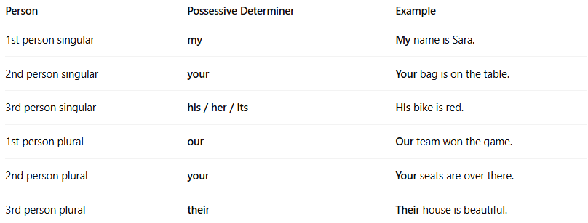
Person | Possessive Determiner | Example
1st person singular | my | My name is Sara.
2nd person singular | your | Your bag is on the table.
3rd person singular | his / her / its | His bike is red.
1st person plural | our | Our team won the game.
2nd person plural | your | Your seats are over there.
3rd person plural | their | Their house is beautiful.

📚 Notes
# Source: AI Source: Provided by: [Data Path: Persons Table -> ID Column: 1, Name_En Column: Motasem Essam] -> From: [Chatgpt (GPT-4-turbo)] on [7/28/2025]
- Always come before a noun.
- Do not stand alone — they must be followed by a noun.
  - ✅ My book is new.
  - ❌ This book is my. ← Incorrect (should be mine)

🆚 Possessive Determiners vs Possessive Pronouns
# Source: AI Source: Provided by: [Data Path: Persons Table -> ID Column: 1, Name_En Column: Motasem Essam] -> From: [Chatgpt (GPT-4-turbo)] on [7/28/2025]
Possessive Determiner | Used before noun | 👉 This is my pen.
Possessive Pronoun | Replaces the noun | 👉 This pen is mine.

Possessive determiners and possessive adjectives are same thing
# Source: AI Source: Provided by: [Data Path: Persons Table -> ID Column: 1, Name_En Column: Motasem Essam] -> From: [Chatgpt (GPT-4-turbo)] on [7/28/2025]
Yes — Possessive determiners and possessive adjectives are the same group of words — just described using different grammar terminology styles.

✅ The Words Are the Same:
# Source: AI Source: Provided by: [Data Path: Persons Table -> ID Column: 1, Name_En Column: Motasem Essam] -> From: [Chatgpt (GPT-4-turbo)] on [7/28/2025]
- my, your, his, her, its, our, their

🔁 Two Names, Same Function:
# Source: AI Source: Provided by: [Data Path: Persons Table -> ID Column: 1, Name_En Column: Motasem Essam] -> From: [Chatgpt (GPT-4-turbo)] on [7/28/2025]
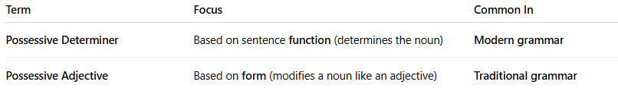
Term | Focus | Common In
Possessive Determiner | Based on sentence function (determines the noun) | Modern grammar
Possessive Adjective | Based on form (modifies a noun like an adjective) | Traditional grammar

📚 Example (same word, two labels):
# Source: AI Source: Provided by: [Data Path: Persons Table -> ID Column: 1, Name_En Column: Motasem Essam] -> From: [Chatgpt (GPT-4-turbo)] on [7/28/2025]
- My car is fast.
✅ In modern grammar, "my" is a possessive determiner (it determines the noun "car").
✅ In traditional grammar, "my" is a possessive adjective (it describes whose car).

🧠 Summary:
# Source: AI Source: Provided by: [Data Path: Persons Table -> ID Column: 1, Name_En Column: Motasem Essam] -> From: [Chatgpt (GPT-4-turbo)] on [7/28/2025]
- ✅ Same words
- ✅ Same usage
- ❗Just two names from different grammar systems:
  - Possessive determiners → modern
  - Possessive adjectives → traditional

